Take a ride with us to analyse the trends or the phenomena in the NY Citi bike Program

Pick up a bike at one of hundreds of stations around Manhattan, Brooklyn, Queens, the Bronx, and Jersey City. See bike availability on the [Station Map](https://member.citibikenyc.com/map/) or [mobile app](http://app.citibikenyc.com/S6Lr/xsceUjcYOF).

Take as many short rides as you want while your pass is active. [Day Passes](https://www.citibikenyc.com/pricing/day) include unlimited 30-min rides and [Annual Memberships](https://www.citibikenyc.com/pricing/annual) include unlimited 45-min rides on a classic Citi Bike.

User Types:

In the data analysed the subcribers are the bike riders with annual membership and customers are bike riders with day passes.

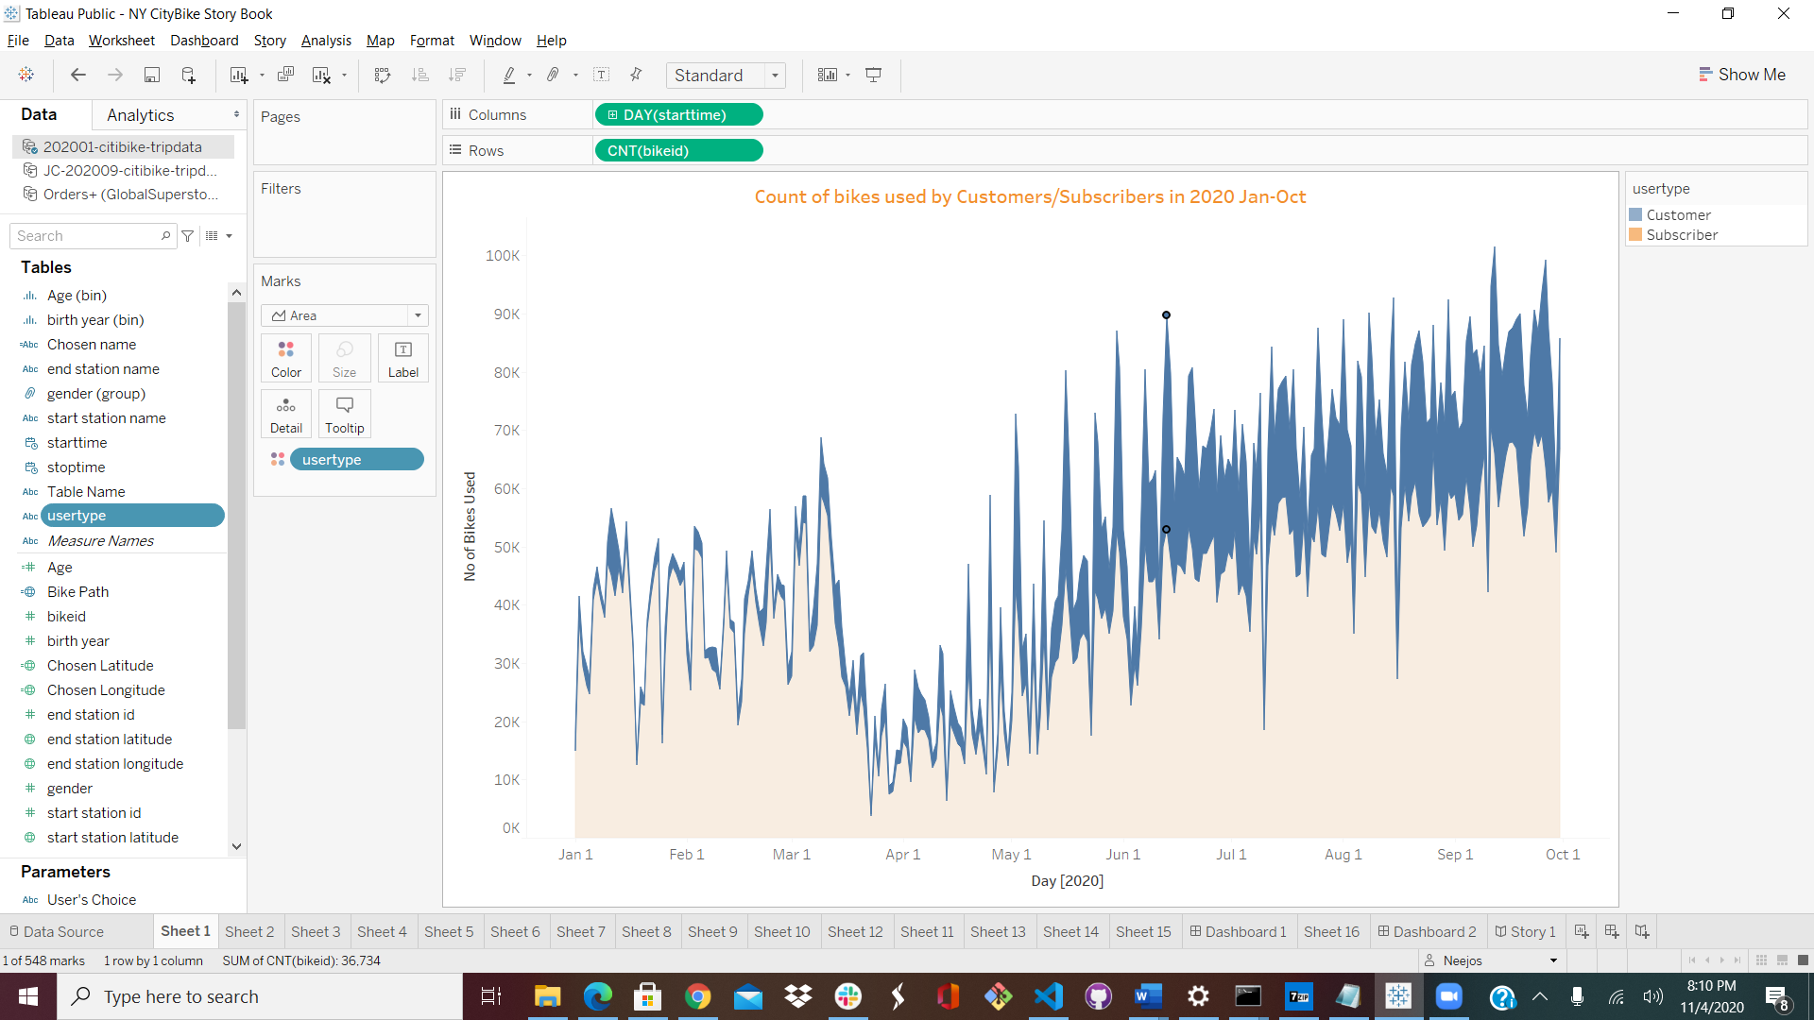

In the above graph it clearly shows there are higher number of Subcribers all year long and this point to the fact that the bike rider program is greatly being accepted.

Percentage Change in bike riders:

Analysis was done about the percentage change in the total no of bike riders by the User type over a 9 month period in 2020 as shown in the below graph. And it shows a deep dip in the riders from March to May and this could be due to the onset of covid pandemic and the resulted lockdown. But then the peak rise in May shows the bike riders are back to enjoy the good weather.

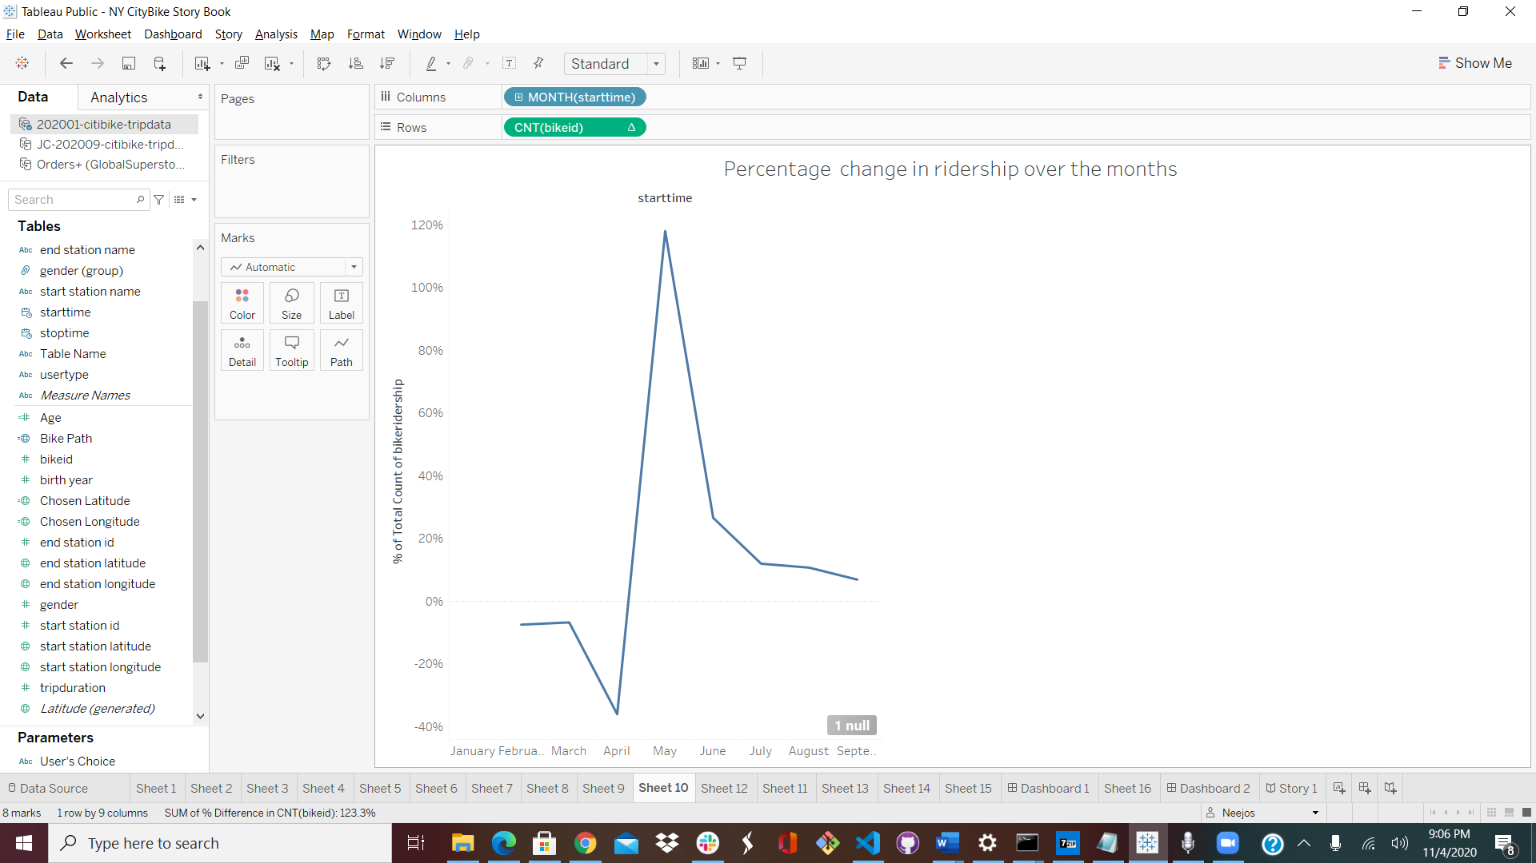

A Surge in Biking to Avoid Crowded Trains in N.Y.C. More New Yorkers are turning to cycling to minimize their coronavirus exposure.

The Peak Hours:

The Peak hours remains to be around 5pm both in Winter and Summer months, as shown in the graphs below but there is a significant increase in the number of riders which could be due to the onset of pleasant weather.

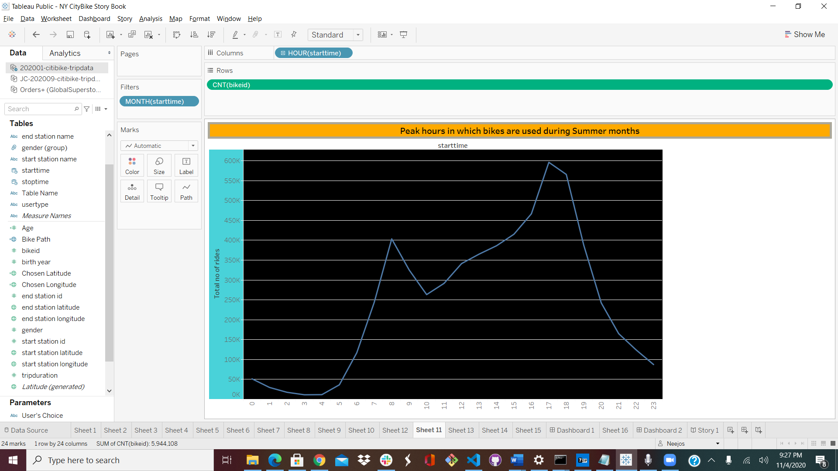 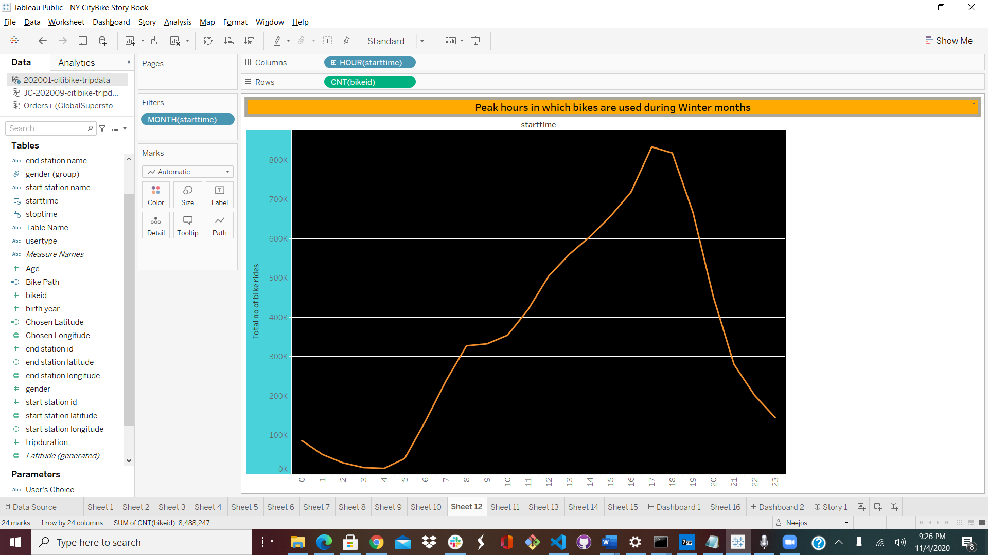

Gender Analysis:

Gender based study was also done to understand the program reach. And it shows a higher percentage of riders are Male which could be the factor the percentage population of males are more than that of females. So comparitively the bike rider percentage would be the same when the population by gender is taken into account.

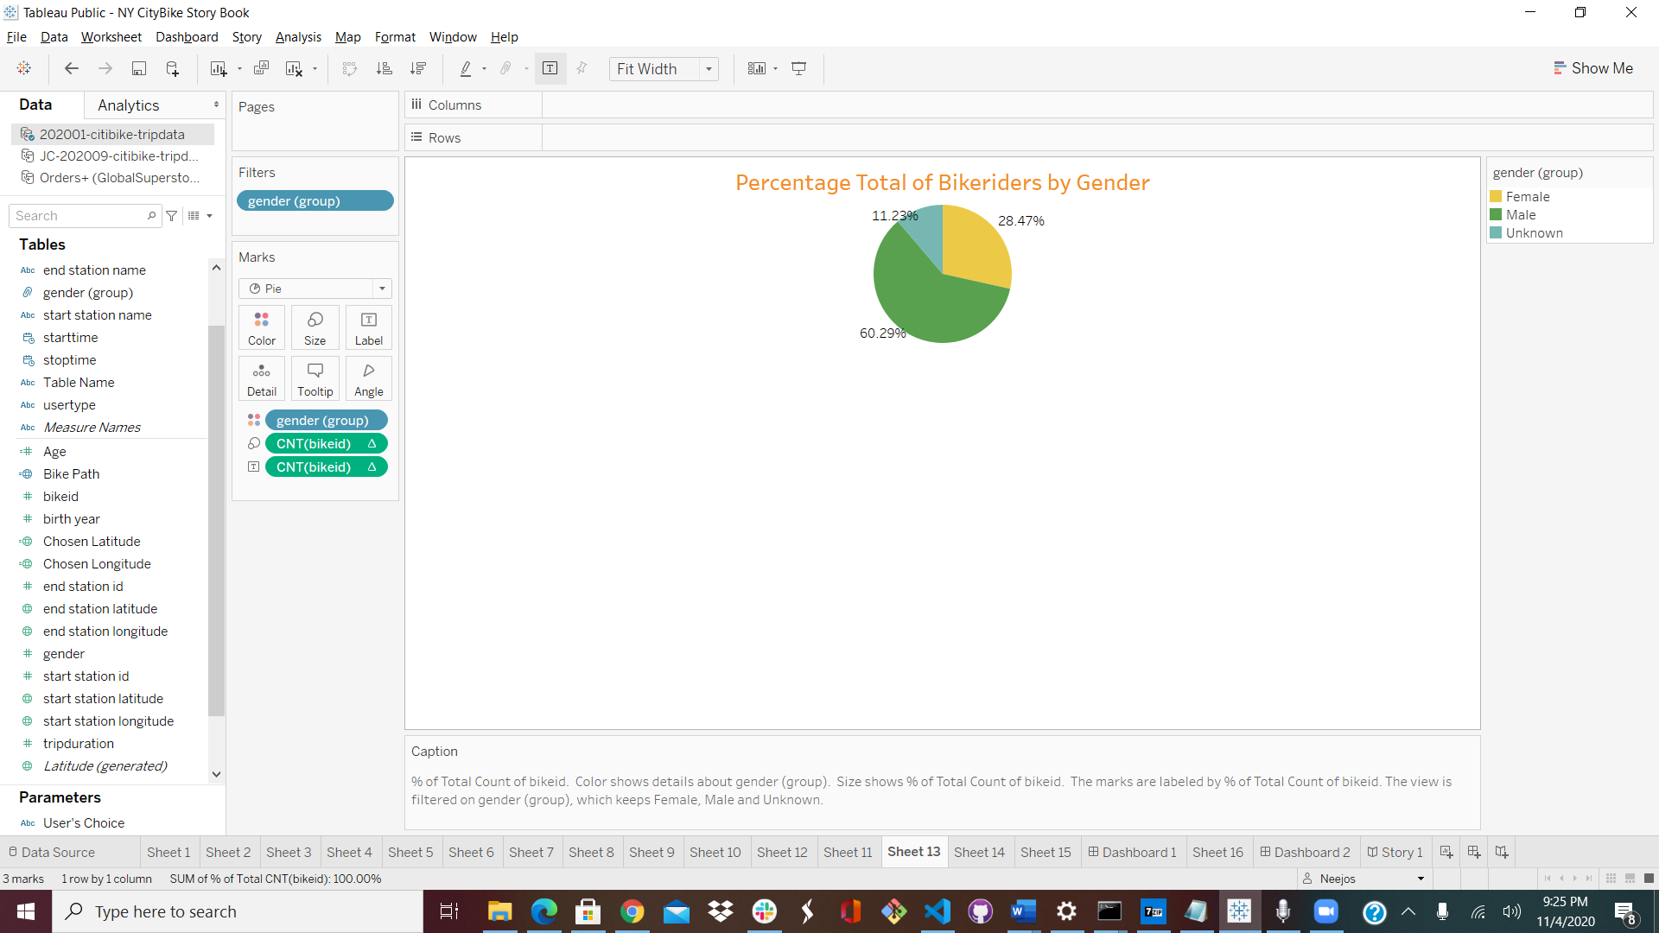

Gender and Age based Analysis:

Clearly the highest number of riders fall under the 21-30 age group followed by 11-20,and within those age groups Male riders are more compared to the other two groups.

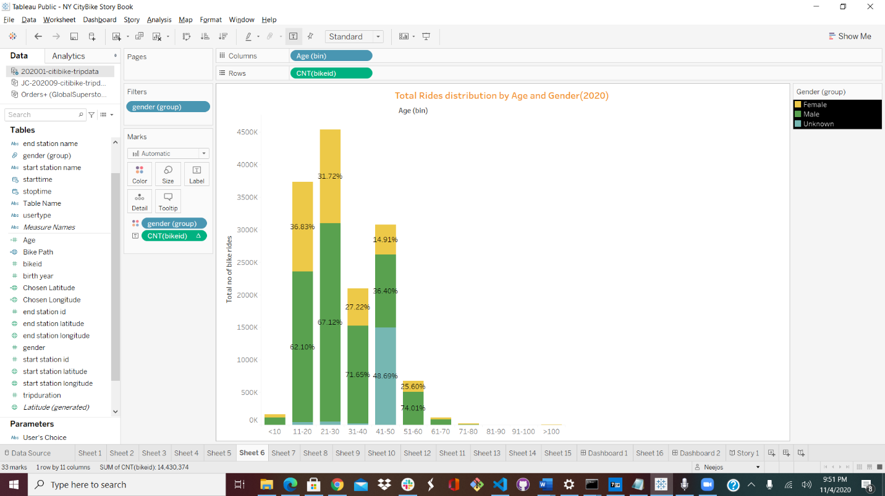

Top 10 Start Stations and End Stations:

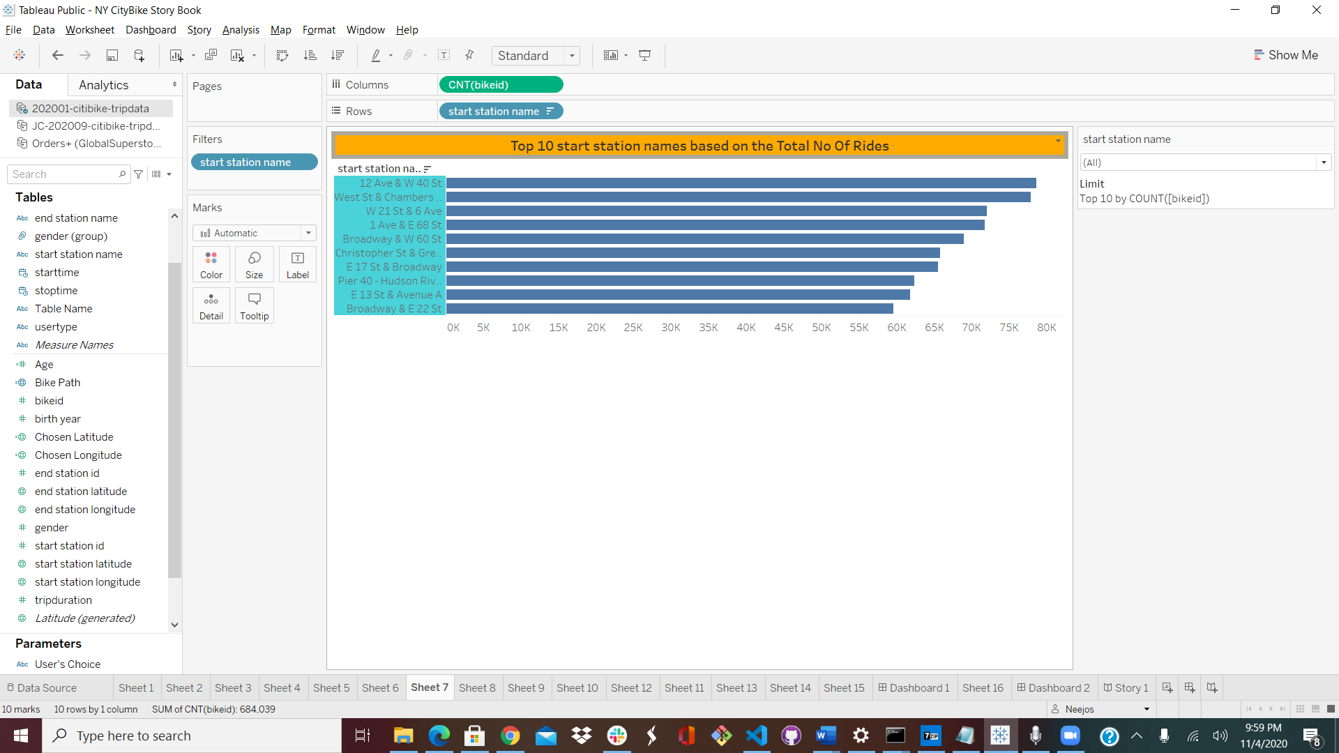

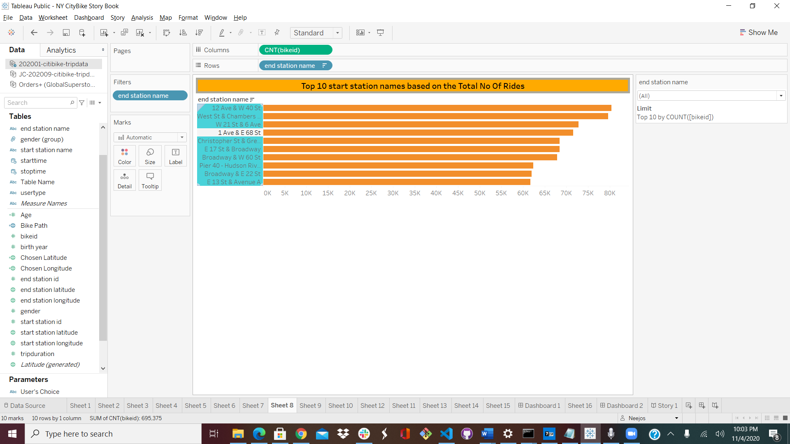

Both the top 10 start and end stations seems to be the same.

Peak Hours over weekdays:

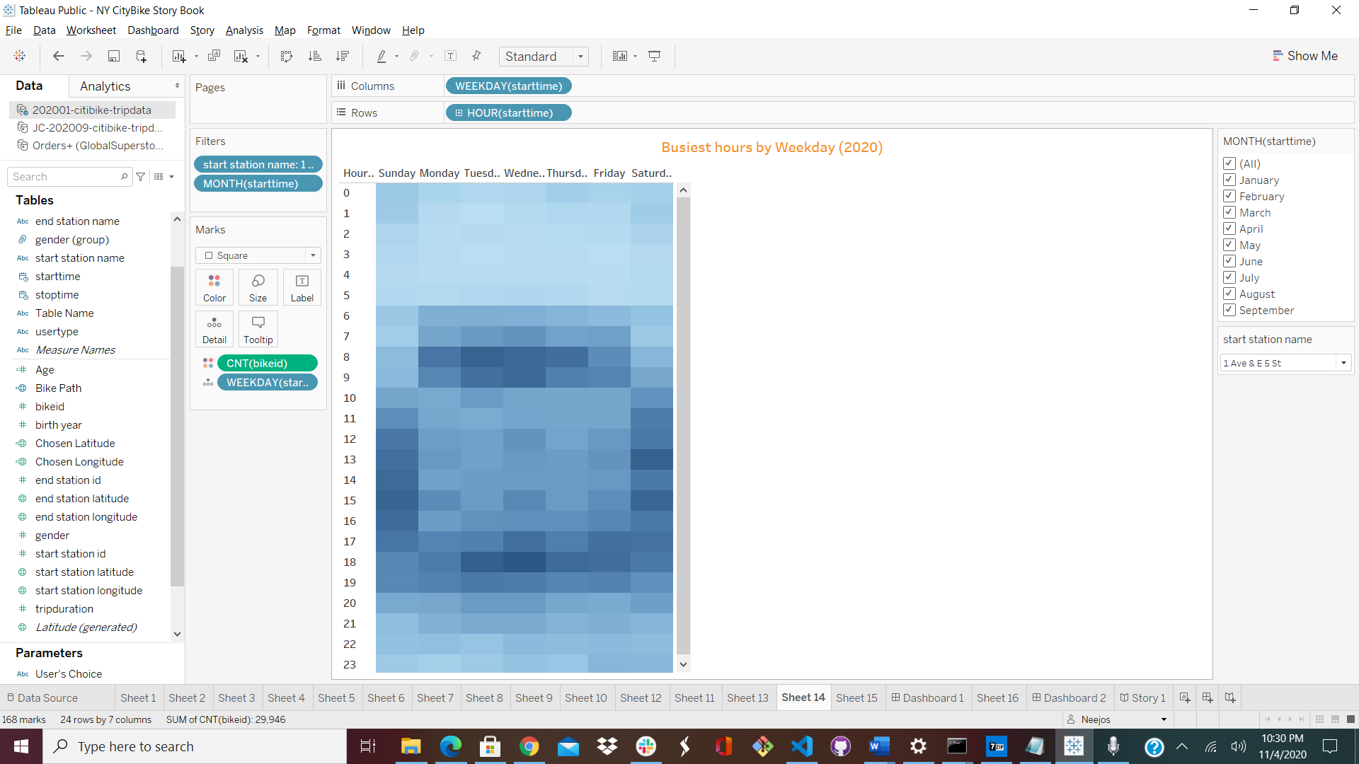

# It’s faster to bike in NYC than it is to take a cab during rush hour and the above graph shows darker cells for higher no of rides during the peak hours.

Popular bike stations:

A dynamic map visualizing the most popular bike rides in the boroughs

